**Title:** Task B-1 Report

**Author:** Robin Findlay-Marks, s103603871

**Task information:**

I found this task to be fairly straightforward. For the candlestick chart, I used the mplfinance from the provided tutorial to make the code. As for the boxplot chart, I used matplotlib to make the boxplot chart. Both the code for the candlestick and boxplots were very, short and straightforward so I believe there is little explanation needed. Both the candlestick and boxplot chart functions (plus included comment explanations) can be seen in figure 01

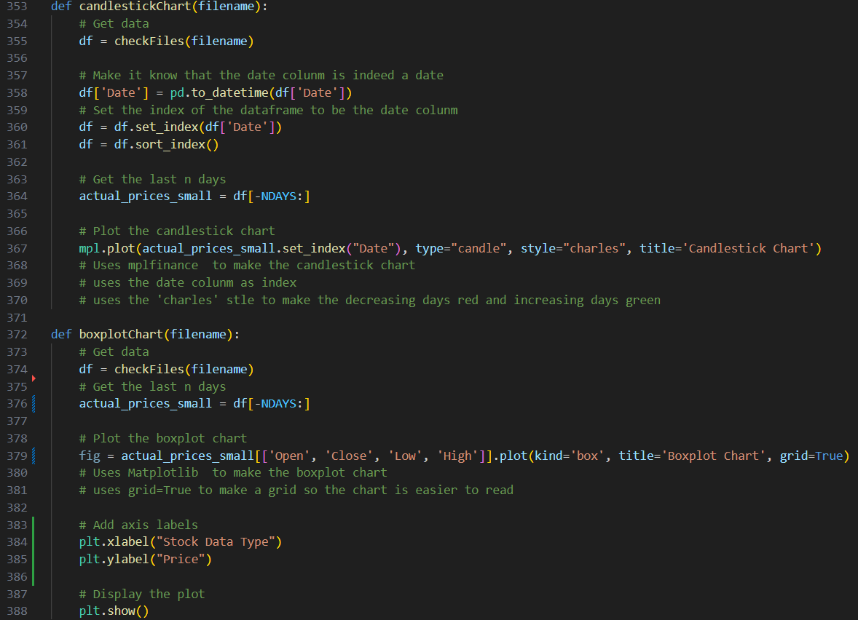

Figure 01

I also restructured the functions from the previous task, made some improvments and I noticed an issue that has now been fixed.

There is now a parameters.py file, that is used to modify the parameters of how the program will run. Additionally the diferent modes of the program are now changd with a single ‘MODE’ variable and the program uses a switch to pick the correct mode

Example of candlestick chart can be seen in figure 02

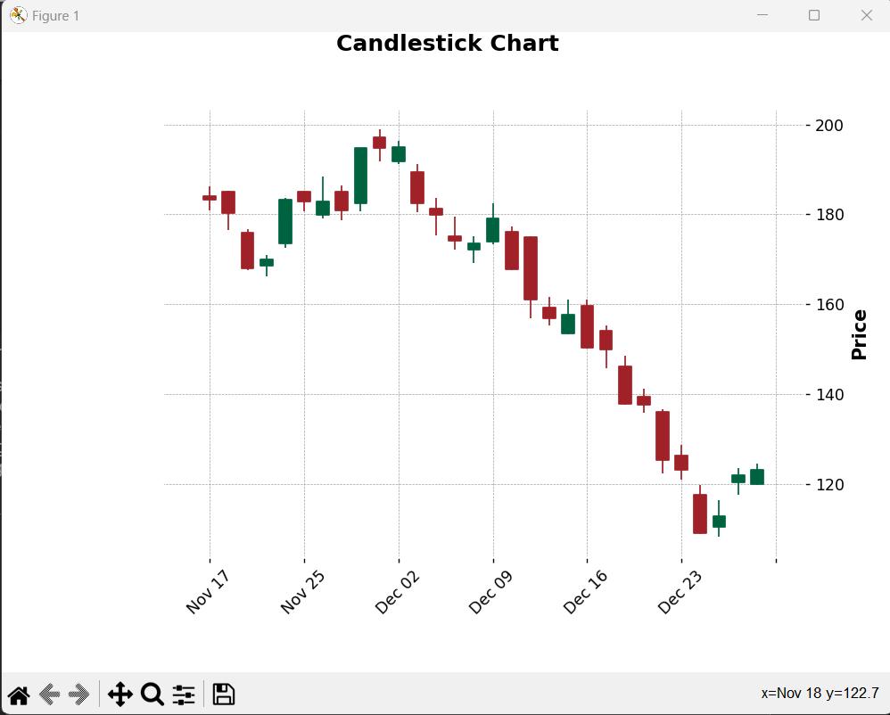

Figure 02

Example of boxplot chart can be seen in figure 03

Figure 03